IOT Traffic Signal Monitoring & Controller System

Here we propose an IOT based automated traffic signal monitoring as well as controller system that automates complete traffic signaling system automation and also allows for manual override over internet. The system uses arduino based circuit system to monitor traffic signal densities and transmits this data online over internet to the controllers. We use IOTGecko in order to develop the online GUI based system to monitor the traffic densities. The system shows current densities to help monitor traffic conditions on roads. Also the system provides an option to the controllers to override any signal and make it green in case of any ambulance or important vehicles to pass through while keeping other signals red. This puts forth a traffic signal monitoring and controller system that can be operated remotely over the internet from anywhere with manual override ability.

Block Diagram: 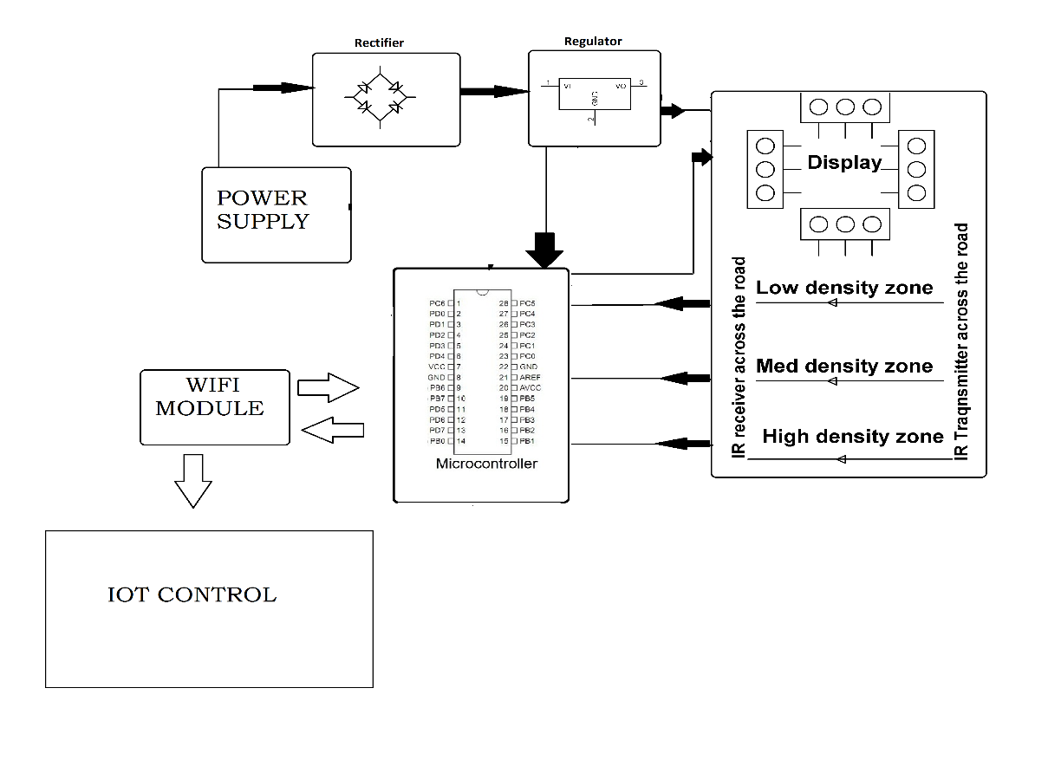
Hardware Specifications :
- Rectifier
- Regulator
- Power Supply
- LCD Display
- Wifi Module
- Led’s
- Atmega 328 Microcontroller
- IR Sensors
- Resistors
- Capacitors
- Diodes

Software Specifications :
- Arduino Compiler
- MC Programming Language: C

